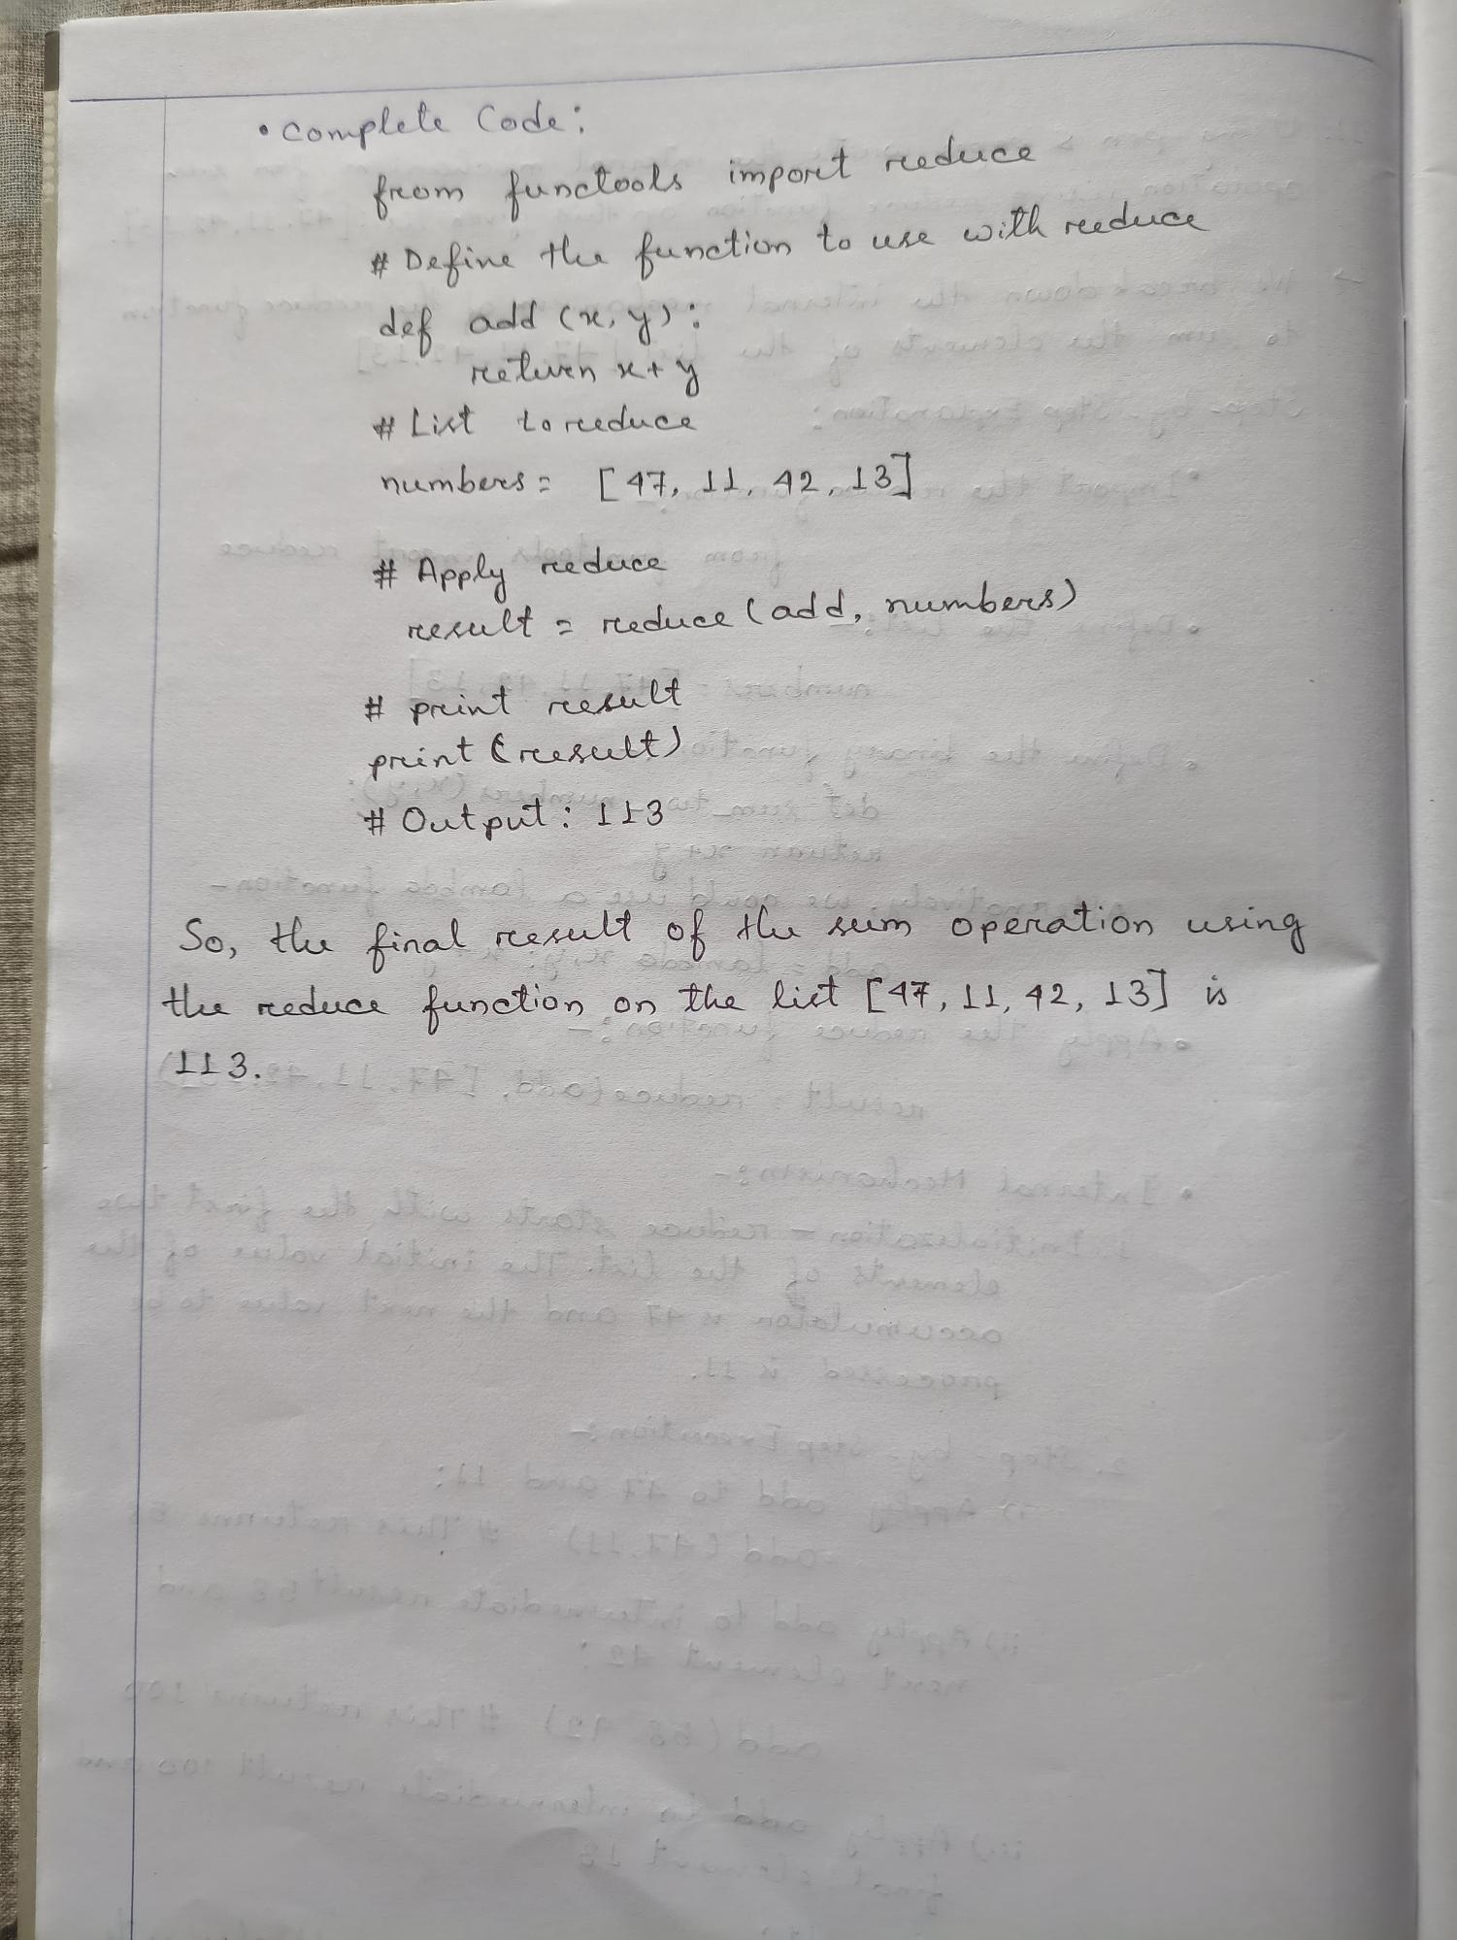

• Complete Code:

from functools import reduce

# Define the function to use with reeduce

def add (x, y):

reliven x+y

У

#List to reduce

numbers = [47, 11, 42, 13]

# Apply

#

reduce

result = reduce (add, numbers)

print resultados

print (result) to

#Output: 113_

201

b

So, the final result of the sum operation using the reduce function on the list [47, 11, 42, 13] is

113. LL FET

Job

ا

song